Всероссийская олимпиада школьников по английскому языку 2017 / 2018
муниципальный этап
7 – 8-е классы стр. 1 из 7

Participant’s ID number
LISTENING
TIME: 15 MIN.

Listen and choose the correct answer A, B or C. You will hear the recording twice.
1. What does Nicky like doing in her free time?
A. watching TV | B. gardening | C. reading the newspaper

2. Where’s Harry going this weekend?
A. a concert | B. the theatre | C. the cinema

3. Who is Jack’s favourite writer?
A. Luigi Pirandello | B. Jack London | C. William Shakespeare

4. What is Ben’s job?
A. a farmer | B. a pilot | C. a jockey

5. Why does Ben think he has the best job in the world?
A. he can risk his life every day | B. he loves being outside all day | C. he likes office work

6. What time does the man want to book the table for?
A. 7.00p.m. | B. 9.15p.m. | C. 8.30p.m.

7. How many people is he going to invite to the restaurant?
A. seven | B. nine | C. eight

8. How many people are going to the concert?
A. seven | B. four | C. six

9. Where did Peter and Françoise meet?
A. Paris | B. Venice | C. London

10. When did they get married?
A. last year | B. last month | C. last week

You now have 20 seconds to complete your task.
This is the end of the listening task.

TRANSFER ALL YOUR ANSWERS TO YOUR ANSWER SHEET

Всероссийская олимпиада школьников по английскому языку 2017 / 2018
муниципальный этап
7 – 8-е классы стр. 2 из 7

Participant’s ID number

READING
TIME: 30 MIN.
I. Read the paragraphs of a Russian fairy tale and put them in order (1 – 7).
a
Once upon a time there lived a rich man who had many servants. One of the servants was Ivan. He was a hunter. One day the rich man sent the hunter into the darkest part of the forest. He wanted Ivan to hunt some animals and birds.
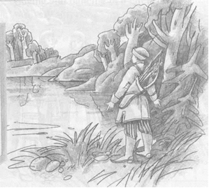
B
She was very upset and began to cry. Ivan was sorry for her. He stepped from behind the stone and returned the shoes to the maiden. She looked into Ivan’s eyes and understood he was in love with her. She liked the young man too. They got married and lived a happy life. …And as for the rich man, he is still waiting for Ivan to return.

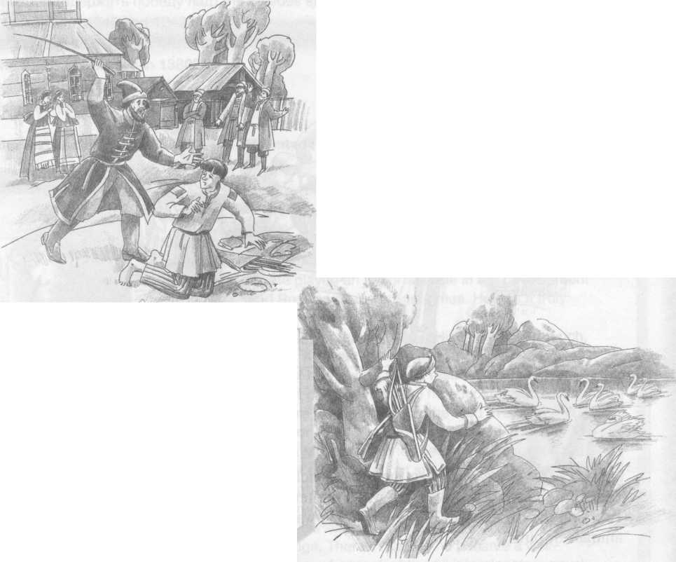
C
The next day the rich man sent Ivan to the forest again. Ivan set out for the Crystal Lake. He came to the lake and hid behind a large stone. Some minutes later the twelve swans flew down and began to splash and play on the water. Ivan couldn’t kill the beautiful birds and returned home empty-handed again. And again he was punished.

стр. 3 из 7
D
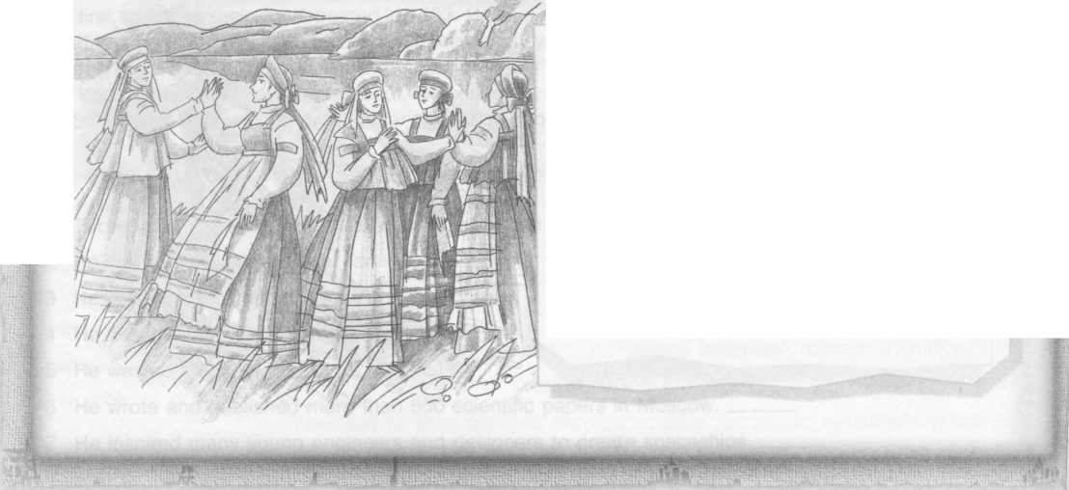
Ivan set out early in the morning. After walking for a long time, he heard the sound of water. Just as the sun cut through the trees, Ivan saw the most beautiful sight he had ever seen. A lake. The lake was as clear as if it was made of glass. He called it “Crystal Lake”.
E
When the maidens finished the dance, they took off their shoes and went for a swim in the lake. Ivan crawled to the shoes and took the shoes of the youngest maiden. Then the maidens stepped ashore, put the shoes back on, turned into white swans and flew away. Only the youngest maiden couldn’t find her shoes and fly away.
F
Twelve snow-white swans were peacefully swimming in the lake. Ivan was so impressed with the beautiful birds that he couldn’t kill them. He came home empty-handed. The rich man was very angry. He ordered punishment for the hunter.
G
Two days later Ivan was given the final chance to hunt. He came to the Crystal Lake again and hid behind the stone. Some time passed and the swans appeared again. They touched the ground and turned into beautiful maidens. The youngest maiden was the most beautiful. The maidens began singing and dancing in a circle. Ivan was very surprised.
1 | 2 | 3 | 4 | 5 | 6 | 7
II. Read the fairy tale again and choose the correct answer A, B or C.
8 | Ivan was | A) a fisherman | B) a hunter | C) a rich man
9 | Ivan was sent to | A) the forest | B) the river | C) the steppe
10 | Ivan found a beautiful | A) river | B) flower | C) lake
11 | There were …swans | A) ten | B) eleven | C) twelve
12 | The swans turned into | A) monsters | B) maidens | C) mice
13 | Ivan took the maiden’s | A) shoes | B) dress | C) hat
14 | The maiden couldn’t fly away because | A) her wings were hurt | B) she liked the lake very much | C) she couldn’t find her shoes

стр. 4 из 7
III. Read the text about a famous Russian scientist and choose TRUE (T) or FALSE (F) for the statements given below.
15 | Tsioikovsky was a famous Russian scientist in the eighteenth century. | T | F
16 | He got his education at home because he had health problems. | T | F
17 | He was an ardent reader. | T | F
18 | He was an engineer. | T | F
19 | He inspired many young engineers and designers to create spaceships. | T | F
20 | He created a rocket in 1903. | T | F
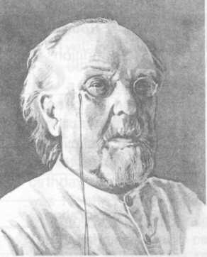
Konstantin Eduardovich Tsioikovsky (1857-1935) was a brilliant Russian scientist and inventor, a pioneer in rocket and space research. He played an important role in the development of the Soviet and Russian space programmes. He was a truly great thinker. He was born on 17 September, 1857. His family was not rich, but it was very large. Konstantin had 17 brothers and sisters. At the age of 10, he lost his hearing as the result of scarlet fever. After that he couldn’t go to school, and he educated himself at home. His books were his teachers, and he read every book in his father’s library. For some years Konstantin lived in Moscow. His visits to the main Moscow libraries helped his education too. At the age of 17, while living in Moscow, he first dreamed about spaceflights. The novels of Jules Verne inspired him. Konstantin not only thought about going into outer space, but also about living in space. After passing his exams, he received his Teacher’s Certificate and began working as a maths teacher. At that time he began his scientific research. From 1892 to 1935 he lived and worked in Kaluga. There in Kaluga he became a well-known scientist and wrote and published his theories of spaceflights and interplanetary travel. His first article on rocketry appeared in 1903. He wrote over 500 scientific papers. He never created any rockets himself, but he influenced many young Russian engineers and designers. Among them was Sergey Korolev, the “Chief Designer” of the Soviet space programme. Konstantin Tsioikovsky, the father of cosmonautics, died in

TRANSFER ALL YOUR ANSWERS TO YOUR ANSWER SHEET

Всероссийская олимпиада школьников по английскому языку 2017 / 2018
муниципальный этап
7 – 8-е классы стр. 5 из 7

Participant’s ID number

USE OF ENGLISH
TIME: 30 MIN.
I. Read the text about a famous museum in London and choose A, B or C to fill in the gaps (1 - 20) below.

THE GEFFRYE MUSEUM
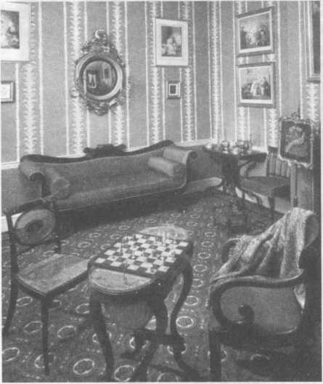
Welcome to the Geffrye Museum, (1)___only museum in the United Kingdom which specializes (2)___furniture and domestic interiors. The Geffrye Museum is one of the most enjoyable museums in London and gives a unique (3) ___to see how English homes (4) ___from the 17th century to the present day. The exhibition (5) ___ as a series of rooms. Each room shows furniture, costumes and interiors of a particular period, for example during the (6) ___ of Queen Victoria. Looking at (7) ___ fashion and scientific progress have developed into the world we know today is very exciting. As you walk along, you can see how the dark and gloomy houses during the period of Henry VIII (8) ___ by the houses of today with central heating and various electric (9) ___. The museum (8) uses the almshouses (10) ___ by Sir Robert Geffrye in 1715. Almshouses were houses for old people who did not have (11) ___ money. Robert Geffrye was a wealthy and successful merchant who (12) ___ his fortune through trade with India and China. For his good deeds and success in business, Sir Geffrye even served as (13) ___ of London. The Geffrye almshouses became a museum in 1912 (14) ___ and encourage local furniture makers. Today, (15 ) ___ museum is not only a collection of English furniture and interiors (16) ___ also an active education centre. (17) ___ and young people can come here to learn the basics of design, and also to take (18) ____ in theatre shows, lectures and seminars. The Geffrye Museum also has a beautiful herb garden where people can see herbs from many countries and learn how different herbs can (19) ___ for medicine, cosmetics and (20) ___.
стр. 6 из 7
1 | A) ------- | B) the | C) a
2 | A) in | B) on | C) at
3 | A) possibility | B) chances | C) opportunity
4 | A) develop | B) have been developing | C) developed
5 | A) is designing | B) have been designed | C) is designed
6 | A) reign | B) rain | C) rein
7 | A) when | B) how | C) why
8 | A) was replaced | B) have replaced | C) have been replaced
9 | A) gadgets | B) devices | C) software
10 | A) building | B) build | C) built
11 | A) any | B) no | C) some
12 | A) did | B) made | C) had
13 | A) Mayor | B) Major | C) Marine
14 | A) support | B) to support | C) supporting
15 | A) -------- | B) a | C) the
16 | A) and | B) but | C) so
17 | A) Children | B) Child | C) Childrens
18 | A) fun | B) time | C) part
19 | A) be used | B) to be used | C) used
20 | A) cooks | B) cook | C) cooking

II. Match the abbreviations from the messages (21 - 30) with their meanings (A - J).

21 | 22 | 23 | 24 | 25 | 26 | 27 | 28 | 29 | 30

21 | F2T? | A | Ta ta for now.
22 | CU2DAY | B | Laughed out loud
23 | TT4N | C | By the way
24 | @ J’S. CUL8TR | D | Are you OK?
25 | BTW | E | Free to talk?
26 | NO 2MORO WER? | F | In my opinion
27 | LOL | G | No. Tomorrow. Where?
28 | IMO | H | At 7. That’s all for now. See you.
29 | RU OK? | I | At John’s. See you later.
30 | @7. TA4N. CU | J | See you today.

TRANSFER ALL YOUR ANSWERS TO YOUR ANSWER SHEET

Всероссийская олимпиада школьников по английскому языку 2017 / 2018
муниципальный этап
7 – 8-е классы стр. 7 из 7

Participant’s ID number
WRITING
TIME: 45 MIN.
INTRODUCTION:
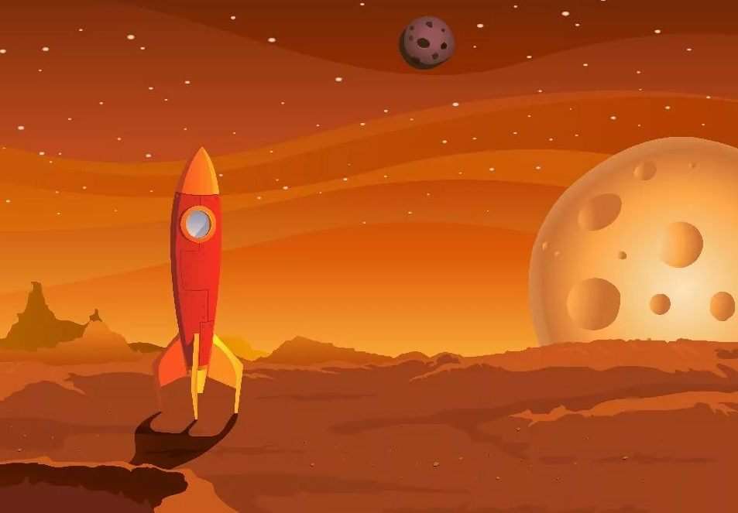
The international team of scientists is working on a project of sending a spaceship to Mars. They have recently discovered that life really exists on “the Red Planet”. The scientists and astronauts truly believe that Earthlings and Martians can become friends and communicate. So, they are asking teenagers all over Earth to write letters to Mars with the purpose of establishing friendly relationship. Please, take part in this project and write a letter to one of the Martians.
A LETTER TO MARS
REQUIREMENTS
In your letter you should:
- be nice;
- tell about life on Earth as you see it;
- ask a Martian 3 questions about their life;
- add P.S (postscriptum) with a joke / suggestion / remark / invitation (you choose);
- follow the standard form of writing letters;
-sign your letter as Your friend from Earth (do not give your real name);
-write 120 – 140 words. You have 45 minutes.
GOOD LUCK!

