Всероссийская олимпиада школьников по английскому языку 2017 / 2018
муниципальный этап
9 – 11-е классы
Participant’s ID number
LISTENING
Time: 15 minutes
HILLSIDE
Survival school
Learn to survive in the wilderness

How long could you survive in the wilderness?
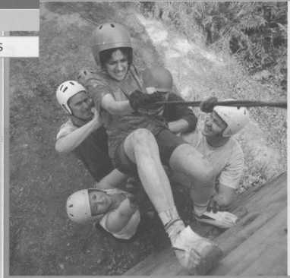
TASK 1. Listen to a talk by David Johnson of the Hillside Survival School and complete the notes with ONE word according to what you hear.
Introduction
David’s current job: 1) school’s chief _________
David’s previous work:
- Other survival schools and the 2) ____________
His aims:
- help people discover nature and the 3)__________ life;
- to remind people that there is more to life than 4) __ living.
- to help people work as a 5) ______________.

Two groups of people the courses are popular with:
- work colleagues and 6) ____________________________

Basic survival course:
How long for? - 7) a ________. When does it take place? – Throughout the 8) ____.

Extreme survival course:
When does it take place? – Between November and 9) ______________.
The course offers you a chance to 10) ______ yourself, both physically and mentally.

TASK 2. Listen again and choose T – true, F – false or NS – not stated for numbers 11 – 15.
11 | David Johnson is the founder of Hillside Survival School. | T | F | NS
12 | Right now he is talking to a group of friends. | T | F | NS
13 | Extreme survival course is longer than Basic survival course. | T | F | NS
14 | Most people join the Extreme survival course in February because the conditions are more difficult. | T | F | NS
15 | Basic survival course is 20 pounds per person cheaper than Extreme survival course. | T | F | NS

You now have 20 seconds to complete your task.
This is the end of the listening task.

TRANSFER ALL YOUR ANSWERS TO YOUR ANSWER SHEET

