XVIII Всероссийская олимпиада школьников по английскому языку 2016 / 2017
муниципальный этап
9 – 11-е классы

Participant’s ID number
LISTENING
Time: 15 minutes

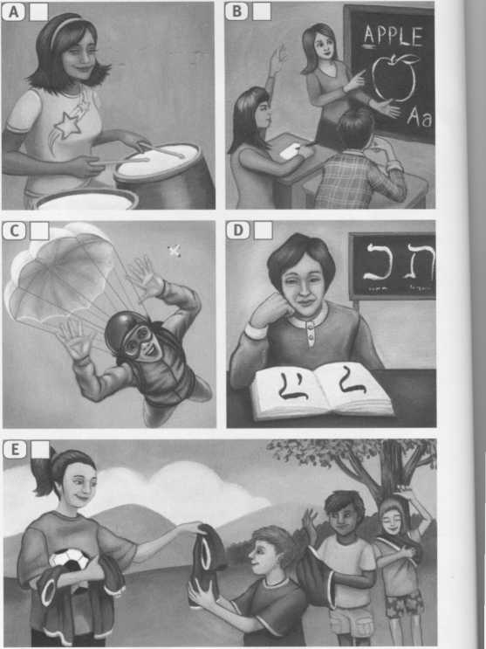
TASK 1. Listen to five speakers describing a learning experience. Match the speakers (1 - 5) with the pictures (A - E).
TASK 2. Listen again and fill in the gaps
(6 - 15) with ONE WORD according to
what you hear.
Natalie started playing the drums when she
was (6) ____. When she was (7) ___ she
was given her first drum kit.
Phil started learning Yiddish a year and a half
ago and did a week intensive course last (8)___
He found it quite easy because he had
studied (9) ____at school.
When Rachel got a job at a kids’ camp
she was surprised that she had no (10) ___
to herself. It felt like being a (11)____.
Sean asked for a (12) ___ jump for his
18th birthday. He went on a one-day (13) ____ course with other students.
Yvette took a job in Indonesia and as she’d never been to Asia before there was a (14) ___ shock for her at first. The job was challenging because apart from giving classes she had to manage four (15) ____.
TRANSFER ALL YOUR ANSWERS TO YOUR ANSWER SHEET

