Speaking
Карточка участника

Student 1

Task 1
(Monologue; Time: 2 minutes)

- Imagine that you are a young INVENTOR who has been invited to a radio show called “Panel of Testers” to speak about your 2 latest useful and eco-friendly gadgets. The PRESENTER of the programme will listen to your speech and ask you 1 question about each gadget. In the end of the programme ONLY ONE gadget will be chosen for further promotion and advertising on the radio by the voting of the listeners and the opinion of the PRESENTER.

Make a presentation of each of your gadgets following the plan:
- Compare it to something else (it’s kind of…/it looks like…).
- Describe its features (size, shape, material…).
- Speak about its functions.
- Say how eco-friendly it is.
- Speak about its disadvantages.

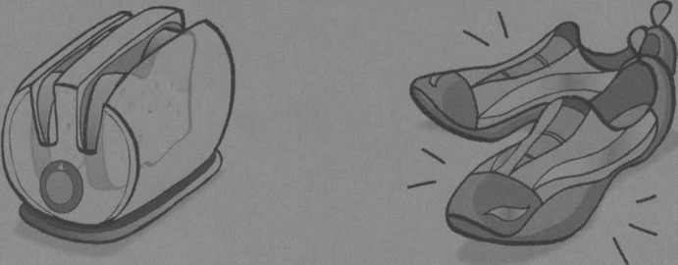

Transparent toaster - watch your toast cook and decide when it’s ready | Light shoes - you don’t need batteries, just walk or run

REMEMBER TO:
- MAKE AN INTRDUCTION AND A CONCLUSION TO YOUR SPEECH.
- GIVE A DETAILED DESCRIPTION OF YOUR INVENTIONS

- After that answer YOUR PARTNER’S QUESTIONS.

Task 2
(Dialogue; Time: 2-3 minutes)

Now you play the role of the radio PRESENTER.

Start the programme. Introduce the guest (Christine / Chris Brainstorm).

Listen to YOUR PARTNER’S speech. Your partner is a young INVENTOR who has created 2 gadgets.

Ask your partner 1 question about the advantages and disadvantages of each gadget and choose ONLY ONE according to the following criteria:
- It is useful;
- It is eco-friendly;
- Most of your listeners like it.

You may disagree with the public opinion and express your own point of view in the CONCLUSION.

You can start the programme using the given INRODUCTION sample:

Hello everyone! This is Juliana / Joe Curiosity and “The Panel of Testers”. In today’s programme we hear from Christine / Chris Brainstorm who has come up with 2 amazing gadgets that are supposed to be widely used by the society and also be friendly to the environment. According to our rules, ONLY ONE gadget will be chosen. Listeners, please, vote, we need to know your opinion. So, Christine / Chris, tell me about the first gadget….

In CONCLUSION sum up your talk and wish your PARTNER Good luck!

YOUR ANSWER WILL BE RECORDED

